**TP MODUL 5**

**NAMA : Ahmad Naufal Ramadhan**

**NIM : 103012300239**

**KELAS : IF-47-02**

Header.h

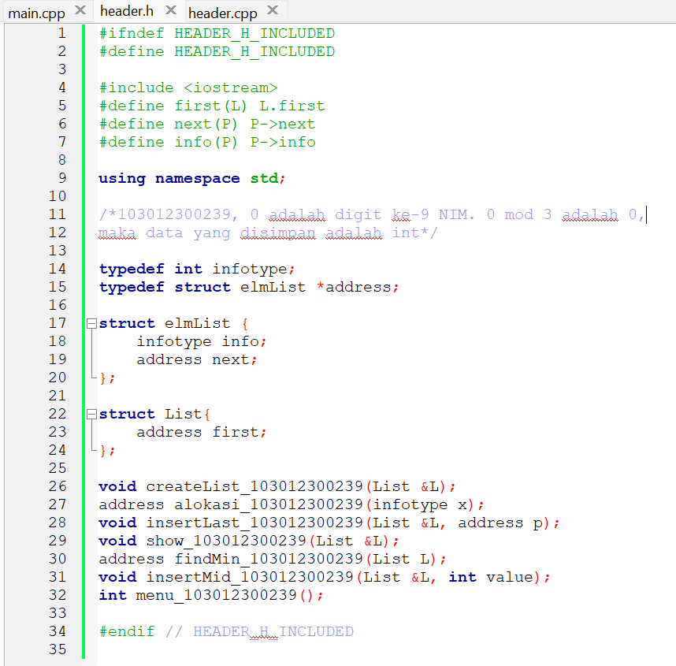

Header.cpp

Main.cpp

running

